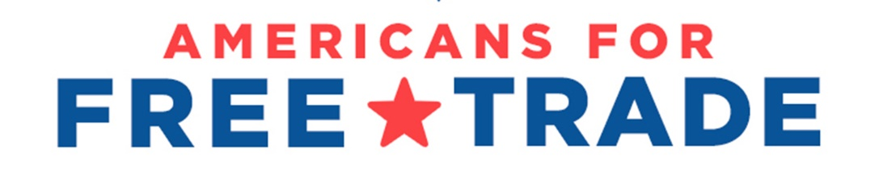
February 28, 2022

The Honorable Chuck Schumer The Honorable Mitch McConnell
Majority Leader Minority Leader
U.S. Senate U.S. Senate
Washington, DC 20510 Washington, DC 20510

The Honorable Nancy Pelosi The Honorable Kevin McCarthy
Speaker of the House Minority Leader
U.S. House of Representatives U.S. House of Representatives
Washington, DC 20510 Washington, DC 20510

RE: Support for Section 301 Product Exclusions Process in China Legislation

Dear Majority Leader Schumer, Minority Leader McConnell, Speaker Pelosi, and Minority Leader McCarthy:

The Americans for Free Trade (AFT) coalition supports congressional action on bipartisan legislation that will help American businesses and workers compete globally, including against China. Integral to improving U.S. competitiveness is addressing harmful tariffs that have increased costs for American businesses and families. For this reason, we strongly support language included as part of the Trade Act of 2021 in the U.S. Innovation and Competition Act (S. 1260) that would require the Office of the U.S. Trade Representative (USTR) to reinvigorate the exclusion process for products subject to additional tariffs under Section 301 of the Trade Act of 1974. Such a provision enjoyed overwhelming bipartisan support, with a 91-4 vote. We had hoped such language would be included in the America COMPETES Act (H.R. 4521), but regrettably, it was not. As these two China competition bills move towards a conference process, we urge Congress to include language requiring USTR to restart a comprehensive, transparent, and fair exclusions process – with retroactivity – for products subject to the 301 tariffs.

By way of background, Americans for Free Trade represents every part of the U.S. economy including manufacturers, farmers and agribusinesses, retailers, technology companies, service suppliers, natural gas and oil companies, importers, exporters, and other supply chain stakeholders. Collectively, we employ tens of millions of Americans through our vast supply chains.

As companies in the U.S. continue to recover from the global pandemic, face supply chain disruptions, and operate in an inflationary economic environment, we continue to call upon the administration to use more strategic tools to address China’s unfair trade practices without damaging U.S. competitiveness. To date, U.S. Customs and Border Protection has assessed nearly $127 billion dollars in tariffs from U.S. companies who import products from China. These taxes increase the cost of doing business in the United States and place a financial burden on U.S businesses – negatively impacting their ability to invest in their companies, hire more American workers, and remain competitive globally.

While we continue to call for an end to the additional tariffs on U.S. companies as well as China’s retaliatory tariffs, we believe reinstituting the section 301 exclusion process is critical to providing interim relief for U.S. businesses. According to a recent Moody’s Investor Service Report, the tariffs “hit American businesses and consumers hardest,” with China absorbing only 7.6 percent of the tariffs “while the rest of the tab was picked up by Americans.” Further, recent articles have highlighted that the tariffs are having a modest but real impact on inflationary pressures. A new, comprehensive, transparent, and fair exclusions process would help alleviate the economic burden on American businesses and consumers.

We welcomed USTR’s announcement in October to open an exclusions process for a limited set of products. However, that process is only available to approximately 1 percent of the original exclusion applications and USTR has yet to announce any new exclusions from the process. To provide meaningful relief, a more robust process is needed. This view is shared by at least 141 bipartisan House members and 41 bipartisan Senators who recently wrote to Ambassador Tai urging USTR to open a broader exclusions process.

Absent a clear indication from USTR that it will use its authority to provide a comprehensive, transparent, and fair exclusions process, Congress must act. We therefore urge Congress to include language in a conferenced China bill that would require USTR to reinstitute a comprehensive, transparent, and fair exclusions process – with retroactivity – for products subject to the section 301 tariffs.

Sincerely,

See the attached list of articles discussing the section 301 China tariffs’ contributions to U.S. inflation woes.

