U.S. COALITION FOR THE UN FOOD SYSTEMS SUMMIT ENGAGEMENT

Thank you for joining the U.S Coalition for the United Nations Food Systems Summit Engagement!

Organizational Information
- Full Coalition calls will be planned for a set time every three weeks. Please fill out this doodle poll by COB Monday, March 29.
- Weekly, the Coalition will receive update emails on key activities related to Summit activities. After the email is sent, you can find these updates on this google drive here.

Working Group Structure
The best way to get engaged is to join (or lead/co-lead) a working group. The working group structure is below. Please reach out to Allie Graham (alliegraham@fooddirectionsdc.com) if you are interested in joining a working group.

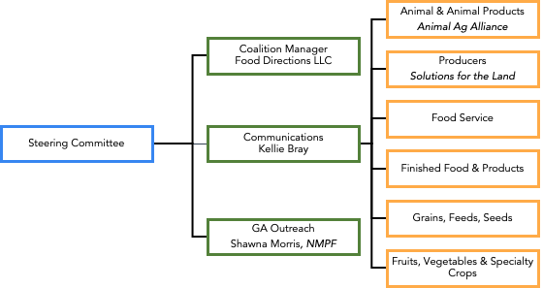

Engagement and Messaging Survey
If you have not already done so, please fill out the welcome survey.
- The survey is intended to gauge any outreach done by coalition members up to this point to leverage the work that has already been done and not duplicate efforts. Additionally, it collects information needed to inform our communications material development.
- Please answer fully and to the best of your ability as this will begin our tracking of activities. Respond here by COB Wednesday, March 31.

FD Team Contact Information
The Food Directions Team will act as a coordinator of coalition activities. Our team contacts are listed below.
- Primary/General Contact: Allie Graham, Food Directions alliegraham@fooddirectionsdc.com
- Communications: Melissa San Miguel, Red Flag, melissa.sanmiguel@thisisredflag.com
- International: Ted Mckinney,Mckinney Agri-Global LLC tmackag@gmail.com
- Congressional/WH: Tara Corrigan, Messina Group, tara@themessinagroup.com

